For submission in: ?

**Artificial night at light differentially affects birds in isolation or social conditions**

Cassandra K. Hui1*, Yong Zhang2, Jenny Q. Ouyang1

1 Department of Biology, University of Nevada, Reno

1664 N Virginia St, Reno, NV 89557

2 Department …

*Corresponding author: chui@nevada.unr.edu

**Abstract**

Artificial light at night (ALAN), a growing pervasive pollutant, disrupts physiological and behavioral rhythms across organisms. However, the influence of social contexts on ALAN's effects has been notably overlooked, despite their significant role in shaping the daily lives and internal biological rhythms of humans and many other species. In this study, we explore how dim ALAN affects zebra finches (*Taeniopygia guttata*) in both social and solitary environments, examining behavioral, physiological, and molecular rhythms. We found that social birds under ALAN had an earlier activity onset and greater disruption in hypothalamic and liver circadian gene expression than controls or isolated counterparts under ALAN. We found no differences in melatonin, possibly due to individual variation. Additionally, we found that activity onset strongly correlated negatively with hypothalamic *Bmal1* and *Cry1* expression and positively with *Per2* expression in birds exposed to ALAN. These results show ALAN’s differential effects on social versus isolated birds and highlight the critical need to consider social contexts in biological studies to better mimic natural conditions.

**Introduction**

**Methods**

*Experimental Design*

99 zebra finches were caged indoors individually (47 x 31 x 36cm cages) or grouped (47 x 93 x 36 cm cages) and entrained to 12 hours light and 12 hours dark (12L:12D) for three weeks. Grouped (social) cages held 3 males and 3 females. For daylight, we used 1.4-Watt 5000 K light emitting diode (LED) rated at 95 Lumens lights at 9:00 (zeitgeber time (ZT) 0) and lights off at 21:00 (ZT 12). Birds were given food and water *ad libitum*. Each cage contained a mechanized perch that relayed hop activity to MATLAB every minute. Cages had individual light-occlusion shades and constant white noise in the background to limit visual and acoustic cues across cages. We also video-recorded cages containing groups of birds every half hour for two minutes (6).

Birds were randomly assigned to one of four conditions: social ALAN (12L:12L dim), isolated ALAN (12L:12L dim), social control (12L:12D), and isolated control (12L:12D). ALAN was standardized to ~5 lux ± 0.01 from a 20 x 1.5 cm 5000 K broad spectrum LED strip using an Extech Easyview Digital Light Meter (model EA13) and lux was calculated using a mean measurement at perch height and two opposing base corners. For a full-spectrum description of the lights, please see (*7*). As determined by One-Way ANOVA, groups did not differ in initial mass (p= 0.25). After the 3-week entertainment period birds were exposed to ALAN for 10 days. We then sacrificed the birds at four time points: ZT 1, ZT 7, ZT 13, and ZT19.

To acquire individual-based melatonin data, we repeated the experiment with new birds collecting blood samples at four different times (ZT 1, ZT 7, ZT 13, and ZT 19) per bird. We collected blood samples after nine days of ALAN exposure at 4 different time points over 10 days (no more than 1% of their body mass per 48 hours).

*Real-Time qPCR*

We used real-time PCR quantification with SYBR-Green to detect circadian gene expression in the hypothalamus and liver. We homogenized the tissues and analyzed in triplicate for technical repeats. We isolated total tissue RNA using Trizol (Life Technologies, Carlsbad, California) and quantified it using Nanodrop 1000 (Thermo Scientific). Reverse transcription was done from 3 mg of total RNA through Versco cDNA synthesis kit. We designed the primers using Primer 3 based on Zebra Finch *Cry1*, *Bmal1*, *Per2*, and *Per3* genes (Table S1). Amplicon abundance was calculated using the 2-∆∆CT method.

*Melatonin*

We measured plasma melatonin concentrations using an enzyme-linked immunoassay kit (Aviva Systems Biology OKEH02566) on 96-well plates according to manufacturer procedures. When available, 25 mL of plasma was diluted (2X) and run in duplicate. The plate was read at 450 nm using a standard microplate reader (BioTek Synergy HTX multi-mode reader) and BioteGen5 data analysis software (BioTek Instruments, Inc, Winooski, Vermont). The interplate CV calculated for xx pooled plasma was xx and the intraplate CV was xxx%.

*Statistical Analyses*

We analyzed all data using R version 4.1.2 (R Development Core Team, 2019). A Welch two-sample t-test was used to test for differences in nocturnal activity between control and ALAN for individually caged and social birds. We used the program Chronoshop 1.1 (freely available; see supplementary) to calculate activity onset (the first time point at which activity is higher than the average) and activity offset (the final time point at which activity is higher than the average) for each day relative to lights on and off. An ANOVA with Tukey’s post hoc comparison was used to determine differences in activity on and offset. Cosinor (version 1.2.3 (Barnett and Dobson, 2010)) was used for rhythmic analysis of melatonin to test for treatment effects on amplitude (i.e. the difference between peak and the mean value of wave) and phase (i.e. time of peak expression in wave). A Student’s t-test with Welch’s corrections was used to test for the effects of ALAN on circadian gene expression at each timepoint. CircaCompare (version 0.1.1) was used for rhythmic analysis of gene expression. We used liner regression models to compare gene expression with melatonin and activity onset. All models met assumptions and significance was taken at α=0.05.

*Ethics Statement*

All procedures were conducted in accordance with the National Institute of Health Ethical Use of Animals and approved by the University of Nevada, Reno Institutional Animal Care, and Use Committee.

**Results**

*Activity*

Exposure to artificial light at night (ALAN) significantly increased nocturnal activity in zebra finches (Figure 1). Perch recordings revealed a notable rise in total nocturnal activity for both isolated (t = 7.18, p < 0.01) and social conditions (t = 6.84, p < 0.01) under ALAN. Additionally, ALAN exposure led to earlier activity onset and delayed offset times across both housing conditions, indicating an extension of the active period in response to artificial lighting (Figure 1B). Birds exposed to ALAN significantly increased their activity onset (Isolated: p < 0.01, Social: p < 0.01) and lengthened their offset (Isolated: p < 0.01, Social: p < 0.01) compared to their controls. However, social birds had a significantly earlier activity onset than isolated birds when exposed to ALAN (p < 0.01).

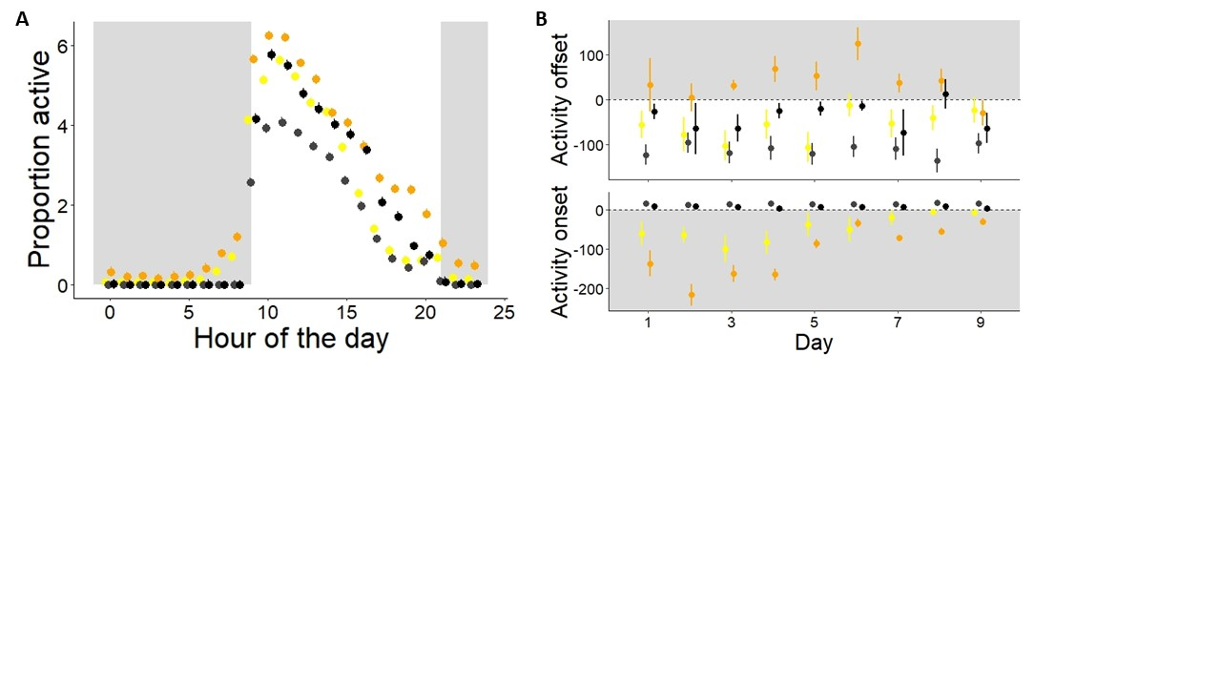

**Figure 1. Activity cycles for birds exposed to dim ALAN across social conditions.** (A) The mean daily activity profile over nine days, comparing ALAN-exposed birds to controls under dark night conditions. Data are reported as mean ± SEM. (B) Comparisons of activity onset and offset times between isolated and social conditions under ALAN exposure and control settings. Data are reported as mean ± SEM.

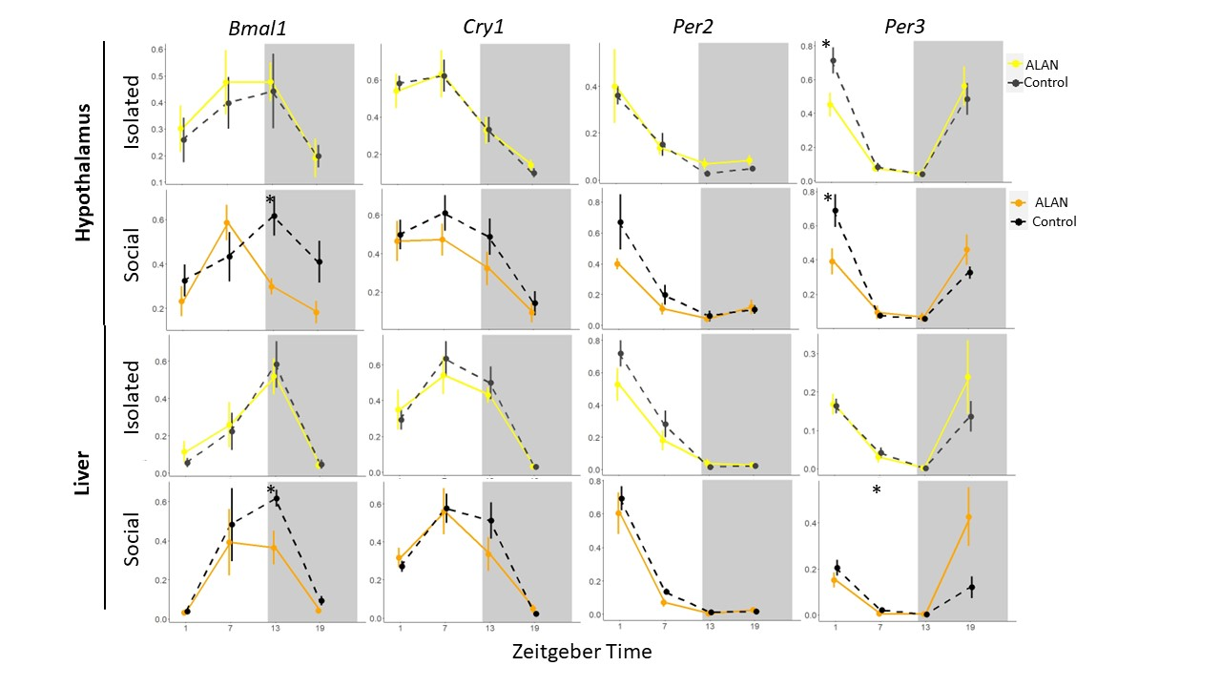

**Figure 2. Daily circadian gene expression in the hypothalamus and liver under ALAN.** Normalized expression of *Bmal1, Cry1, Per2,* and *Per3* collected at four timepoints throughout the day. Shaded portions represent nighttime (ZT 12-ZT 24). Birds exposed to ALAN were significantly different from controls in *Per3* expression at ZT 1 (Isolated: p = 0.03, Social: p = 0.04) and only social ALAN birds were significantly different from social controls in *Bmal1* expression at ZT 13 (p = 0.01) in the hypothalamus. Birds exposed to ALAN in social conditions were significantly different from social controls in *Bmal1* expression at ZT 13 (p = 0.03) and *Per3* expression at ZT 7 (p = 0.05) in the liver. Asterisks: ‘*’ p < 0.05, ‘**’ p < 0.01, ‘***’ p < 0.001.

*Gene Expression*

We observed consistent daily rhythms in the expression of circadian genes *Cry1, Per2,* and *Per3* within the hypothalamus across all treatments (all p-values < 0.01: Figure 2). In contrast, *Bmal1* expression exhibited less pronounced rhythmicity, with variability observed across different conditions (Isolated control: p = 0.08, Isolated ALAN: p = 0.01, Social control: p = 0.03, Social ALAN: p < 0.01). No significant differences were found in the phase or amplitude of *Cry1, Per2,* and *Per3* expressions between control and ALAN-exposed groups (Table 1). We identified a significant phase shift in *Bmal1* expression among social ALAN birds compared to their social controls (p < 0.01) and not in isolated conditions (p = 0.77). *Bmal1* expression significantly decreased among socially housed birds under ALAN at ZT 13 (t = -3.30, p = 0.01; Figure 4), that again was not seen in isolated birds (t = 0.22, p = 0.83). However, regardless of social condition *Per3* expression significantly decreased in birds exposed to ALAN relative to their respective controls at ZT 1 (Isolated: t = -2.48, p = 0.03, Social: t = -2.42, p = 0.04).

**Table 1.** Rhythmic analysis comparing difference in phase of expression of four circadian genes in the hypothalamus between birds exposed to ALAN and controls either in isolation or social conditions. Four timepoints were collected throughout the day at ZT 1, 7, 13, and 19.

|  |  |  |  |
| --- | --- | --- | --- |
| **Condition** | **Gene** | **Difference** | **p-value** |
|  | *Bmal1* | 0.70 | 0.77 |
| Isolated | *Cry1* | -0.14 | 0.89 |
|  | *Per2* | 0.61 | 0.63 |
|  | *Per3* | 1.20 | 0.08 |
|  | *Bmal1* | 5.00 | **0.01** |
| Social | *Cry1* | 1.44 | 0.36 |
|  | *Per2* | 0.96 | 0.55 |
|  | *Per3* | 1.70 | 0.05 |

Robust daily oscillations were also found in *Bmal1, Cry1, Per2,* and *Per3* expression in the livers, consistent across all treatments (all p-values < 0.01: Figure 5). Comparisons of phase and amplitude between control groups and those exposed to ALAN showed no significant differences for *Bmal1, Cry1,* and *Per2* expressions. However, the amplitude of *Per3* expression increased in socially housed birds exposed to ALAN (p = 0.05), but not isolated birds (p = 0.26). Differences in individual timepoints were insignificant between isolated birds exposed to ALAN and controls. However, ALAN exposure significantly decreased *Bmal1* expression at ZT 13 (t = -2.60, p = 0.03) and *Per3* at ZT 7 (t = -2.68, p = 0.05) in socially housed birds.

We conducted a correlation matrix analysis to examine the relationship between gene expression levels in the hypothalamus and liver among birds subjected to ALAN exposure and their corresponding controls, across both isolated and social conditions, at every timepoint (Figure 3A). A comprehensive Principal Component Analysis (PCA) of all gene expression data revealed that samples grouped according to timepoint rather than by exposure condition (Figure 3B).

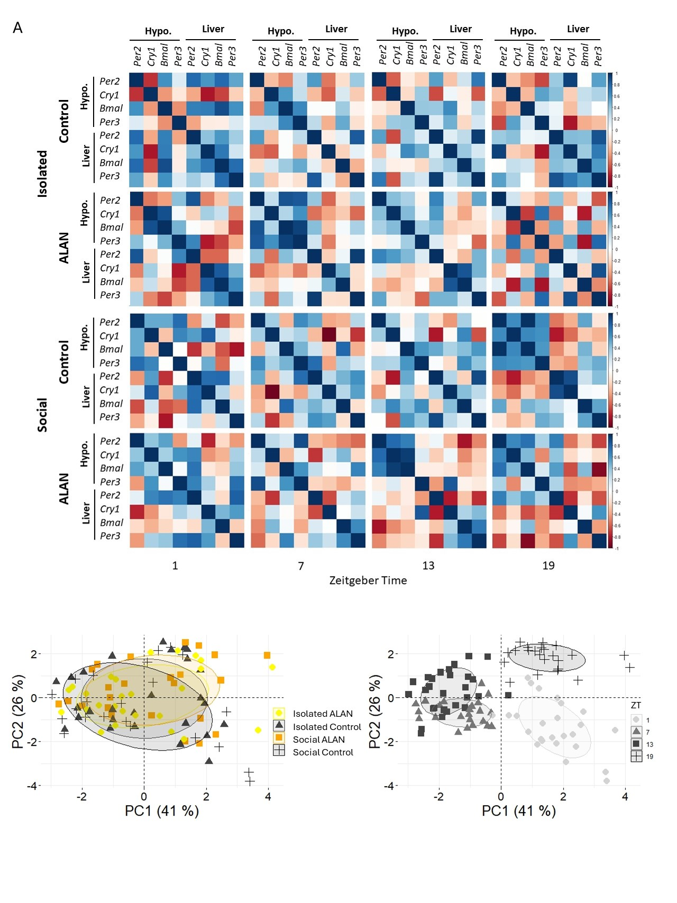

**Figure 3. Correlation matrix and PCA between circadian genes expressed in in the hypothalamus and liver under ALAN in isolation or social conditions.** (A) Matrixes are separated by control or exposre to ALAN and zeitgeber time (1, 7, 13 and 19). Dark blue shows a strong positive correlation and dark red shows a strong negative correlation between four circadian genes (*Bmal1, Cry1, Per2,* and *Per3*) in the hypothalamus and liver. (B) PCA plots of all gene expression in the hypothalamus and liver. Points represent individuals which cluster by timepoint and not treatment, elipsies cover 80% of samples.

*Melatonin*

Melatonin concentrations oscillated throughout the day in all groups, peaking at night for isolated control and social birds, but during the day for isolated birds exposed to ALAN (Figure 4A). The amplitude (Isolated: z = 0.12, p = 0.73; Social: z = 0.04, p = 0.84) and phase (Isolated: z = 0.06, p = 0.81; Social: z = 0.16, p = 0.69) of melatonin did not differ between birds exposed to ALAN and controls regardless of social condition.

*Gene expression and melatonin*

In the hypothalamus, *Cry1* expression exhibited a slight negative correlation with melatonin levels across all treatments, except for isolated birds under ALAN, where a moderate positive correlation was observed (Figure 4B). Linear regression analyses were conducted separately for isolated and socially house birds. For isolated birds, hypothalamic *Cry1* expression moderately correlated with melatonin levels (t = 1.84, p = 0.07) and similarly moderately associated with ALAN exposure (t = 1.78, p = 0.08). Conversely, within social housing conditions, *Cry1* expression strongly correlated with melatonin levels (t = -3.07, p < 0.01), yet showed no significant correlation with ALAN exposure (t = -0.25, p = 0.81).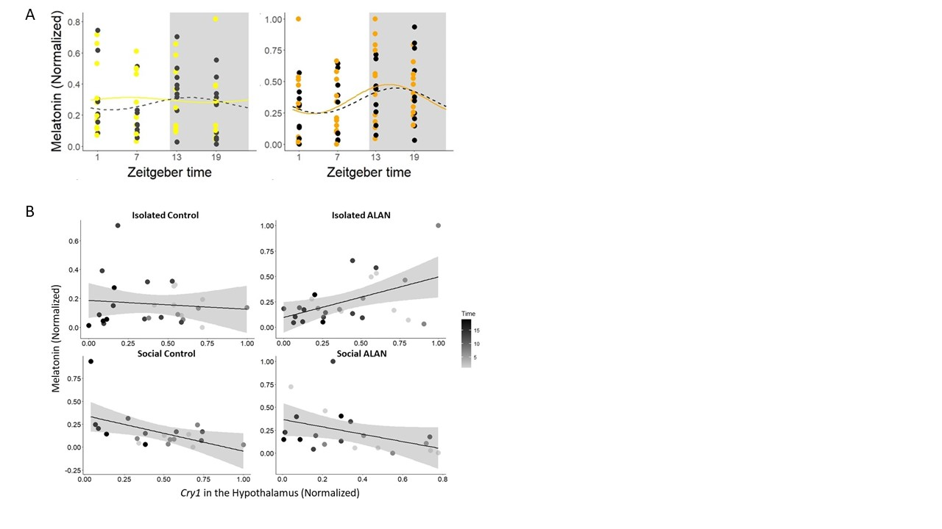

**Figure 4. Daily melatonin levels and interactions with hypothalamic *Cry1* under ALAN across social conditions.** (A) Circadian rhythm of melatonin with fitted cosine curve overlaid. Shaded portions represent nighttime (ZT 12-ZT 24). The left panel shows birds in isolation and the right panel shows birds in social conditions, dark grey is isolated and black is social control, yellow is isolated under ALAN, and orange is social under ALAN. Samples were collected after 10 days of ALAN exposure at ZT 1, ZT 7, ZT 13, and ZT 19. Significant differences were not detected between birds exposed to ALAN and control birds in either isolation or social groups. Points represent individuals. (B) Scatter plots of hypothalamic *Cry1* and melatonin levels normalized across timepoints (grey scale). The top left is isolated controls, top right is isolated birds under ALAN, bottom left is social controls, and bottom right is social birds under ALAN. Lines are fitted as linear regression model and shaded portions represent 95% confidence interval. Points represent individuals.

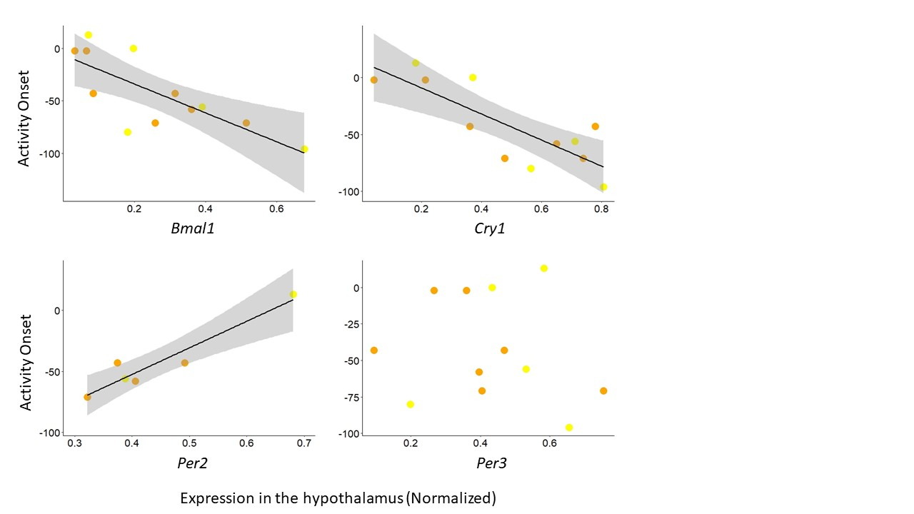

**Figure 5. Hypothalamic circadian genes at ZT 1 predict activity onset.** Circadian genes *Bmal1* (p < 0.01), C*ry1* (p < 0.01), and P*er2* (p < 0.01) expressed in the hypothalamus at ZT 1 predict activity onset of the last experimental day in birds exposed to ALAN. *Per3* (p = 0.58) does not. Lines are fitted with statistically significant linear regression models and shaded portions represent 95% confidence interval. Points represent individuals.

*Gene expression and activity*

Hypothalamic circadian genes (*Bmal1, Cry1,* and *Per2*) expressed at ZT 1 strongly predict (Figure 5; all p < 0.01) activity onset under ALAN, aside from *Per3* (p = 0.58). We did not analyze control birds because they maintained an onset close to 0.

**Discussion**

**Acknowledgments**

**Supplemental**

**Supplementary Table 1:** Primers sequences designed based on Zebra Finch *Cry1*, *Bmal, Per2*, *Per3,* and 18S genes for qPCR.

|  |  |  |
| --- | --- | --- |
| **Primer** | | **Sequence (5’- 3’)** |
| *Cry1* | forward | GGTCTTCTTGCAACTGTGCC |
| reverse | AGCTGAGCTCCTCCTGTACT |
| *Bmal1* | forward | ATGGCTGTCCAGCACATGAA |
| reverse | CACAGCCCACAACGAAAAGG |
| *Per2* | forward | AGCAAGACCTGATGCCTGTC |
| reverse | ACATCGGACGTGAACAA AA |
| *Per3* | forward | TTGTGGCCAAGGTGATTCCC |
| reverse | TGTCTCTGAGGTTTCTGGCG |
| *18S* | forward | GCCGCTAGAGGTGAAATTCTTA |
| reverse | CTTTCGCTCTGGTCCGTCTT |

**References**

1. J. Q. Ouyang, S. Davies, D. Dominoni, Hormonally mediated effects of artificial light at night on behavior and fitness: linking endocrine mechanisms with function. *Journal of Experimental Biology* **221**, (2018).

2. D. M. Dominoni *et al.*, Artificial light at night leads to circadian disruption in a songbird: integrated evidence from behavioural, genomic and metabolomic data. *bioRxiv*, 2020.2012.2018.423473 (2021).

3. O. Siehler, S. Wang, G. Bloch, Social synchronization of circadian rhythms with a focus on honeybees. *Philosophical Transactions of the Royal Society B-Biological Sciences* **376**, (2021).

4. N. A. Jha, V. Kumar, Female conspecifics restore rhythmic singing behaviour in arrhythmic male zebra finches. *Journal of Biosciences* **42**, 139-147 (2017).

5. A. Rath, M. Benita, J. Doron, I. Scharf, D. Gottlieb, Social communication activates the circadian gene Tctimeless in Tribolium castaneum. *Scientific Reports* **11**, (2021).

6. V. J. Alaasam *et al.*, Light at night disrupts nocturnal rest and elevates glucocorticoids at cool color temperatures. *Journal of Experimental Zoology Part a-Ecological and Integrative Physiology* **329**, 465-472 (2018).

7. V. J. Alaasam *et al.*, Effects of dim artificial light at night on locomotor activity, cardiovascular physiology, and circadian clock genes in a diurnal songbird. *Environmental Pollution* **282**, (2021).

8. D. M. Dominoni, R. J. Nelson, Artificial light at night as an environmental pollutant: An integrative approach across taxa, biological functions, and scientific disciplines. *Journal of Experimental Zoology Part a-Ecological and Integrative Physiology* **329**, 387-393 (2018).

9. S. B. Banerjee, E. Adkins-Regan, Effect of isolation and conspecific presence in a novel environment on corticosterone concentrations in a social avian species, the zebra finch (<i>Taeniopygia guttata</i>). *Hormones and Behavior* **60**, 233-238 (2011).

10. K. Spoelstra, I. Verhagen, D. Meijer, M. E. Visser, Artificial light at night shifts daily activity patterns but not the internal clock in the great tit (Parus major). *Proceedings of the Royal Society B-Biological Sciences* **285**, (2018).

11. S. Moaraf *et al.*, Artificial light at night affects brain plasticity and melatonin in birds. *Neuroscience Letters* **716**, (2020).

12. C. K. Hui *et al.*, Dim artificial light at night alters immediate early gene expression throughout the avian brain. *Frontiers in Neuroscience* **17**, (2023).